Name: Nam Jun Lee

WSU ID: 011606459

Assignment: Assignment #4

Class number: 2021 Fall-MIS-325-ONLIN-2217-H72-01-10356-LEC

Date: November 11th , 2021

<https://cb-ot-devst06.ad.wsu.edu/MF13namjun.lee/Assignment4/Assignmnet4.aspx>

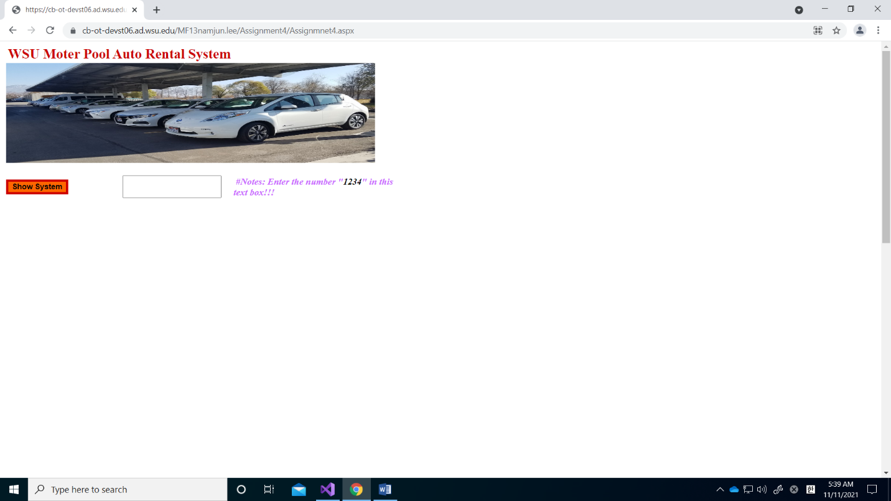

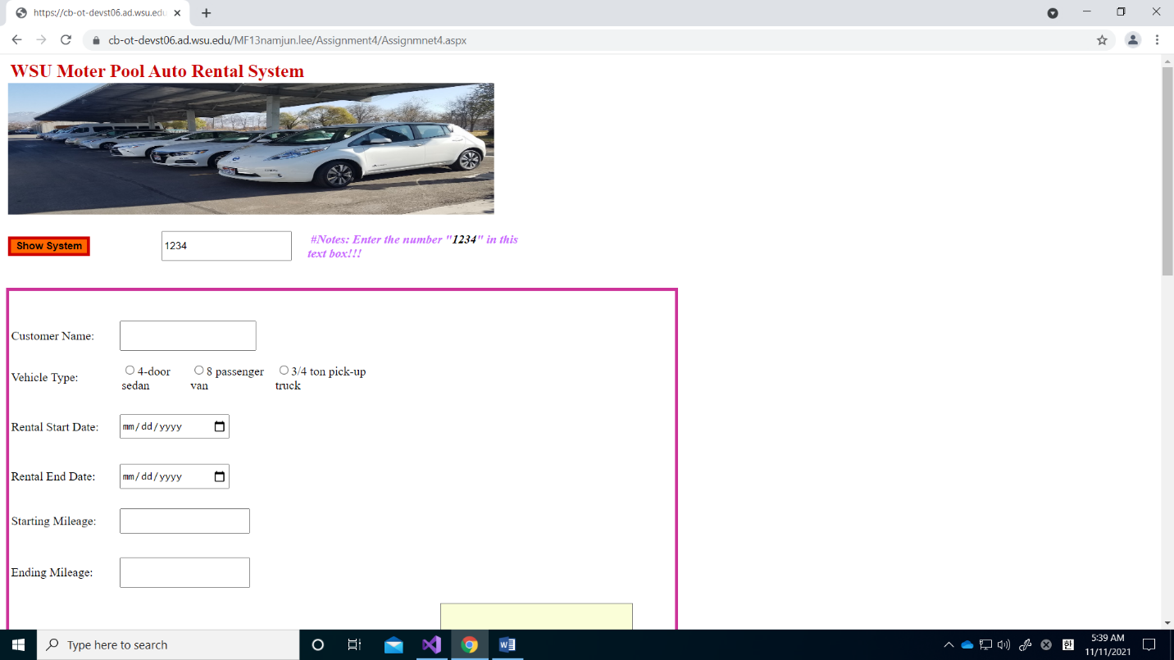

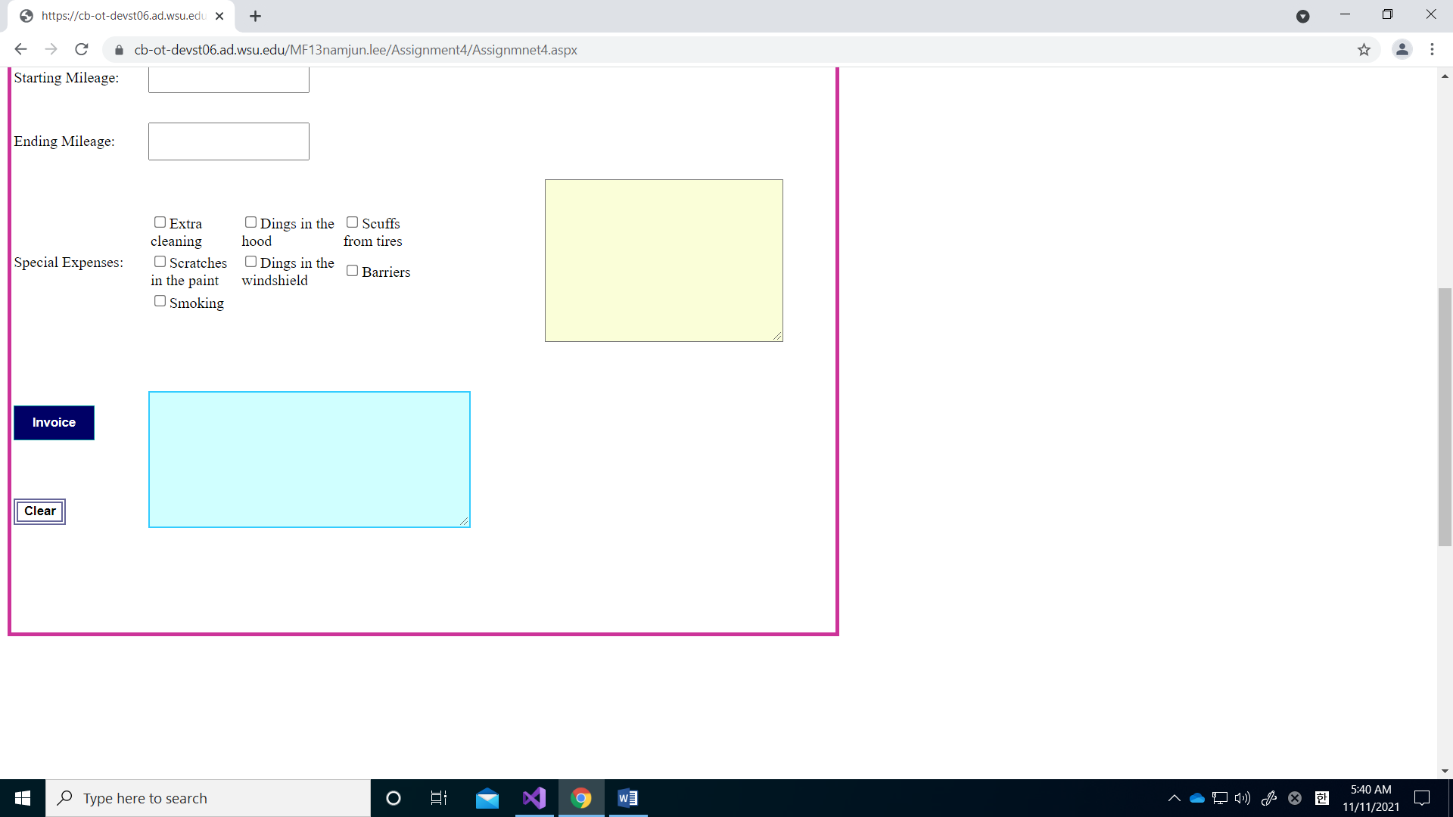

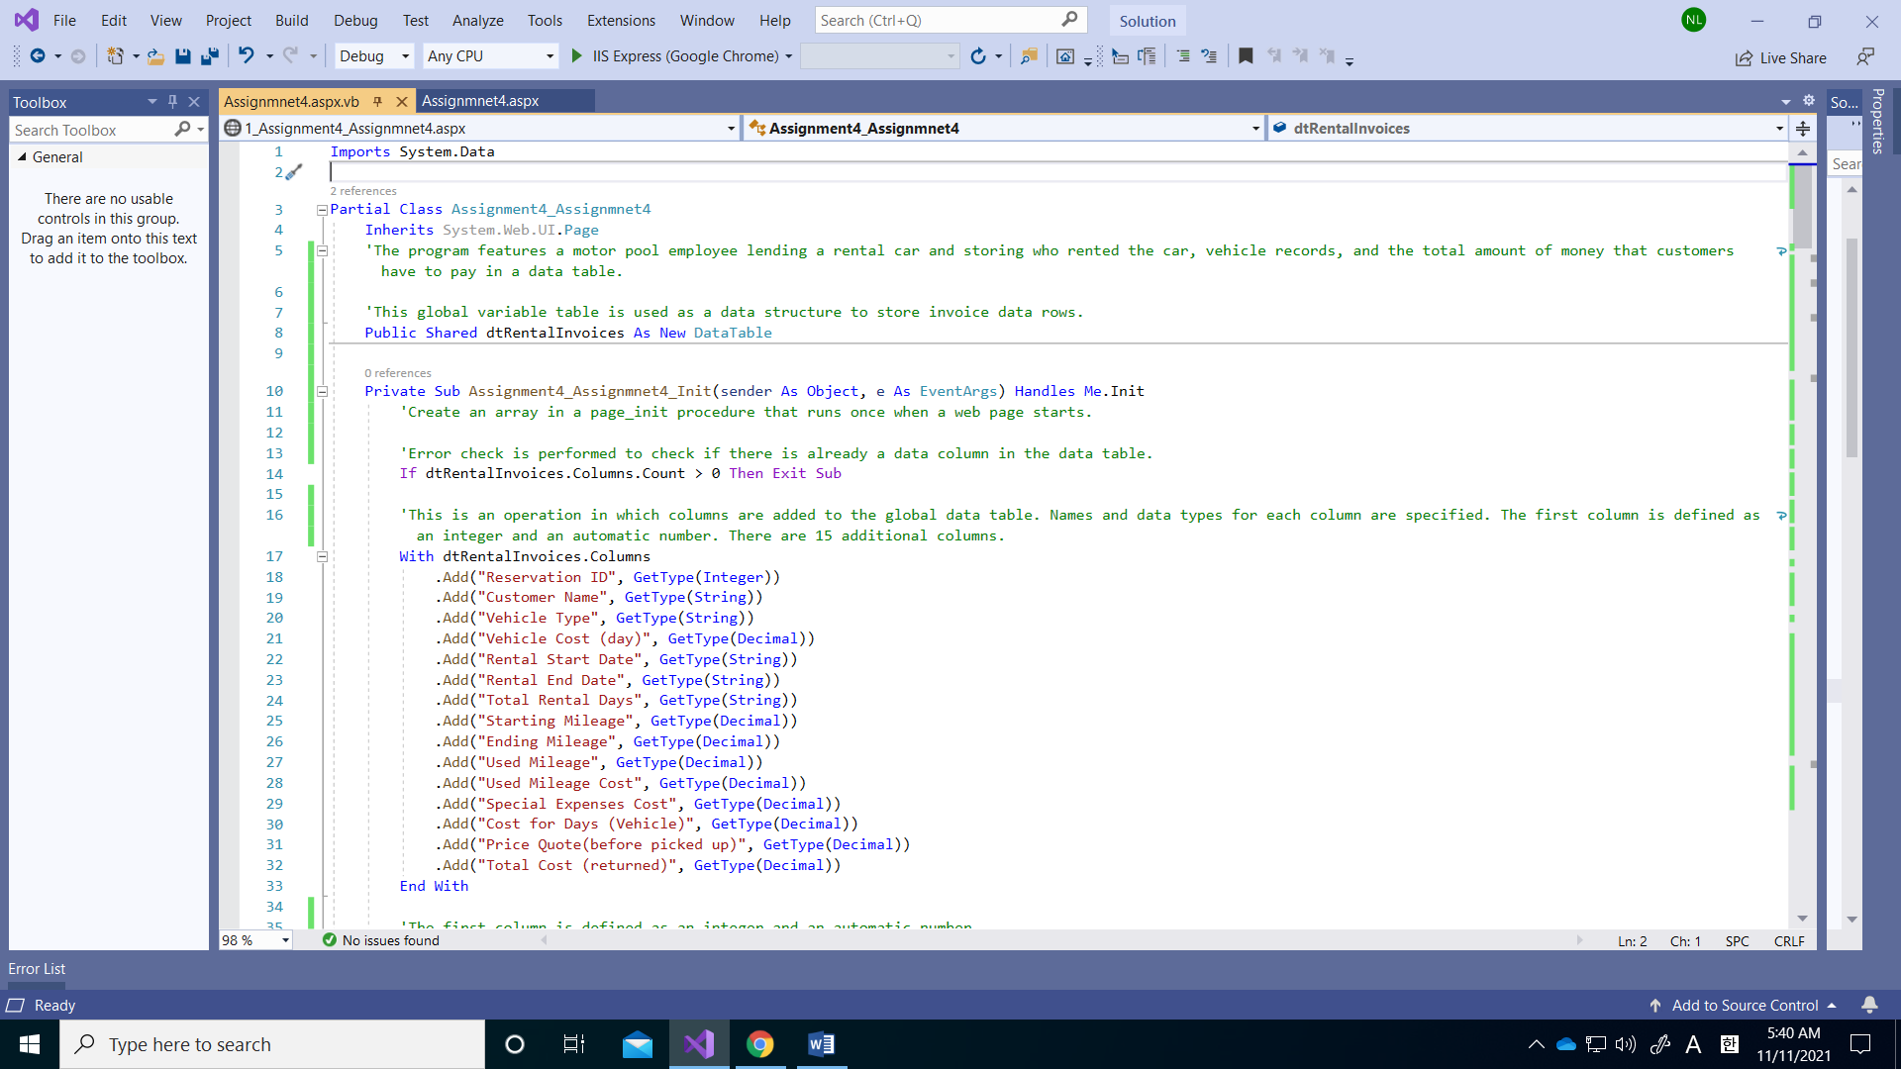

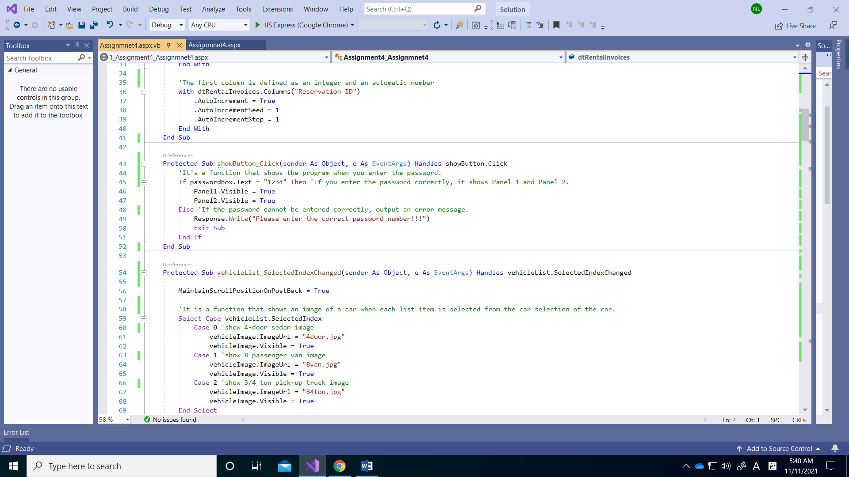

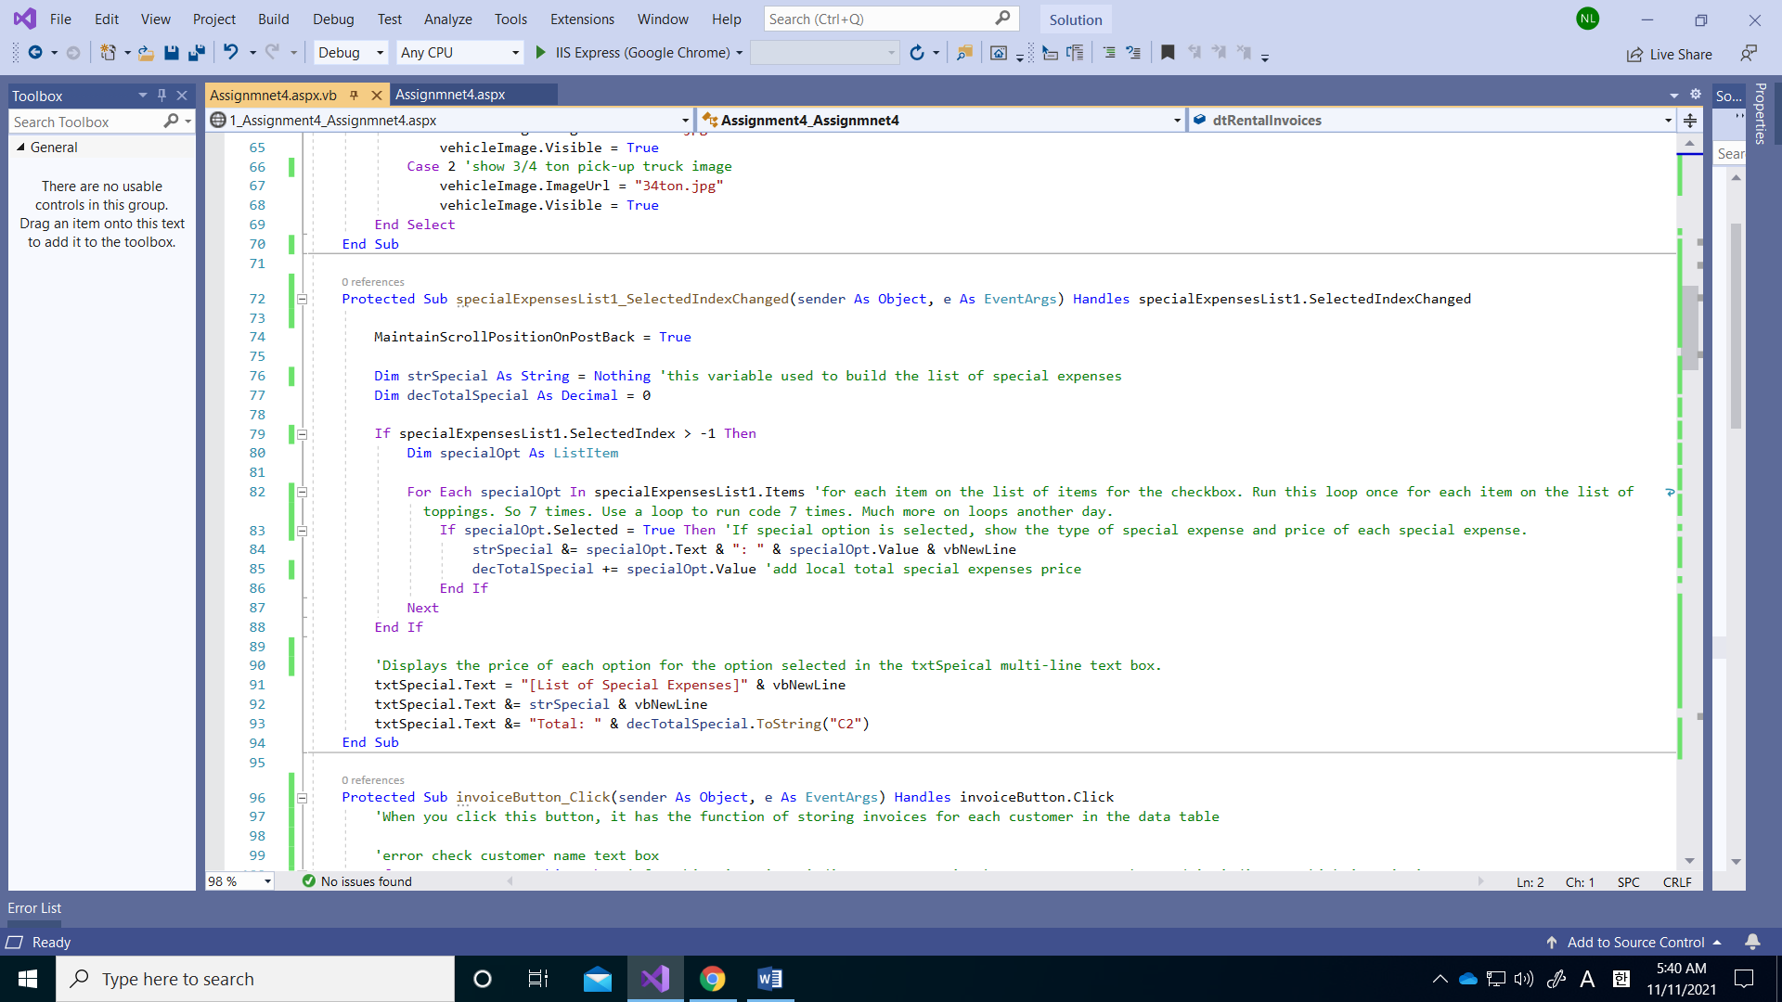

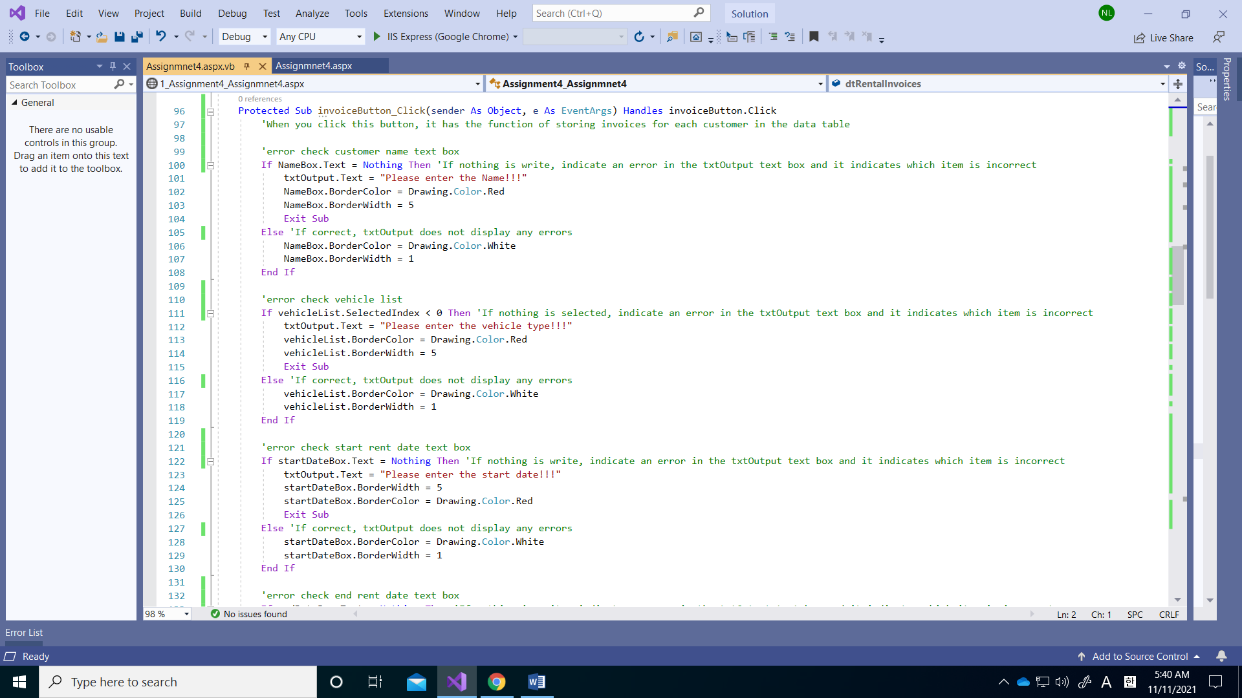

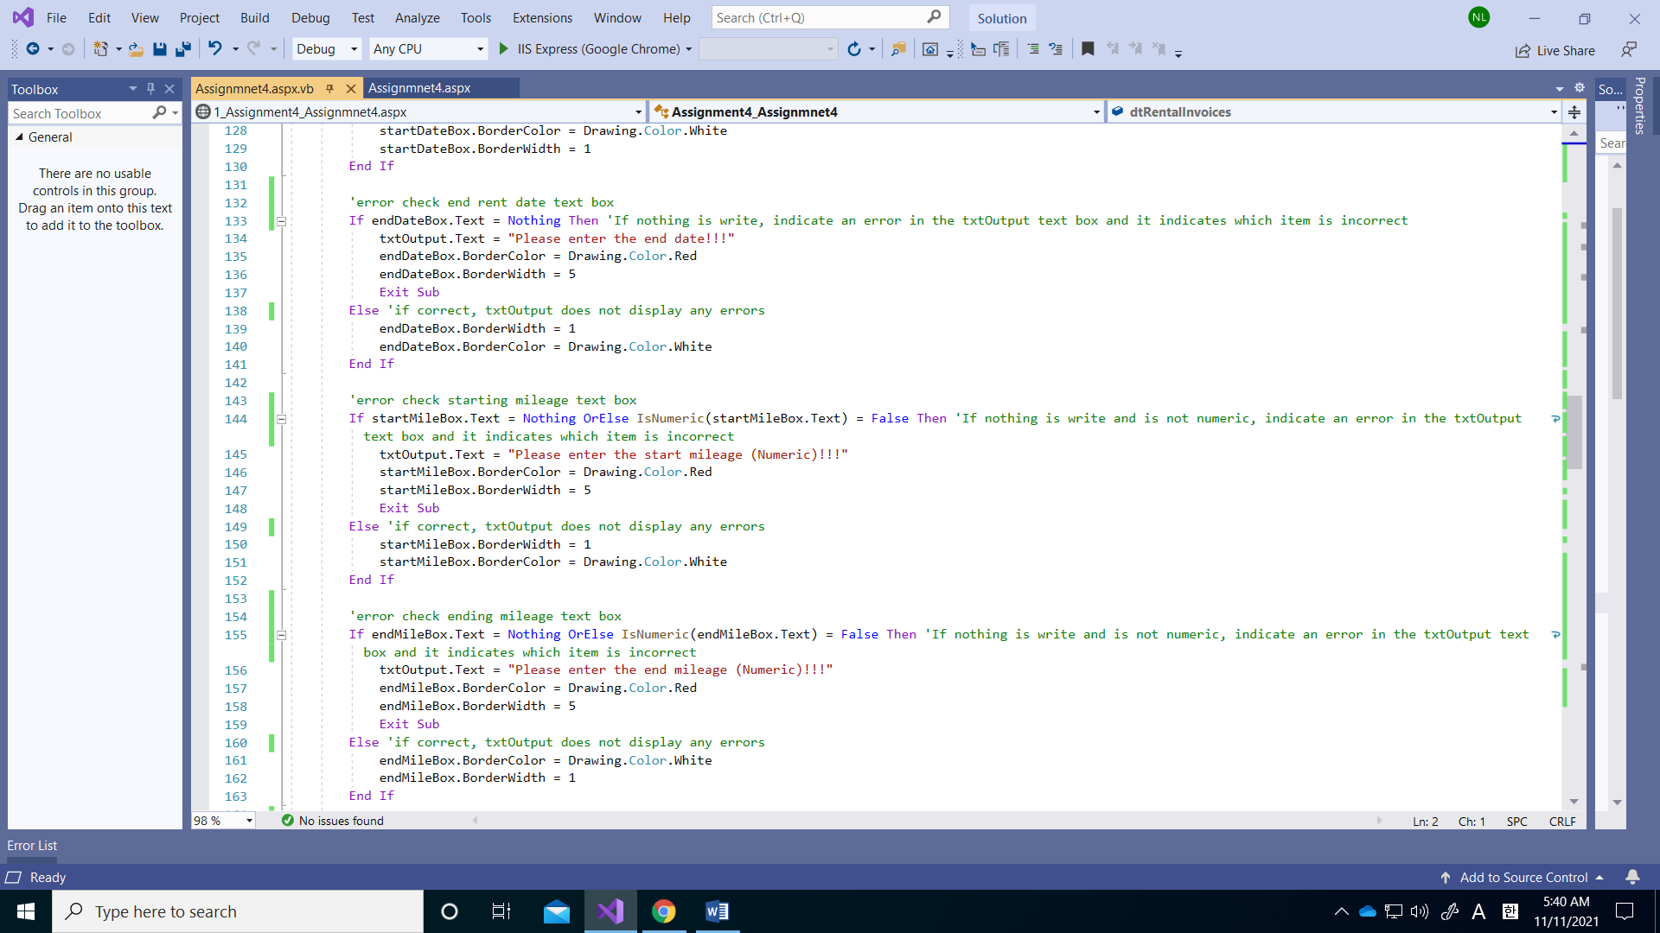

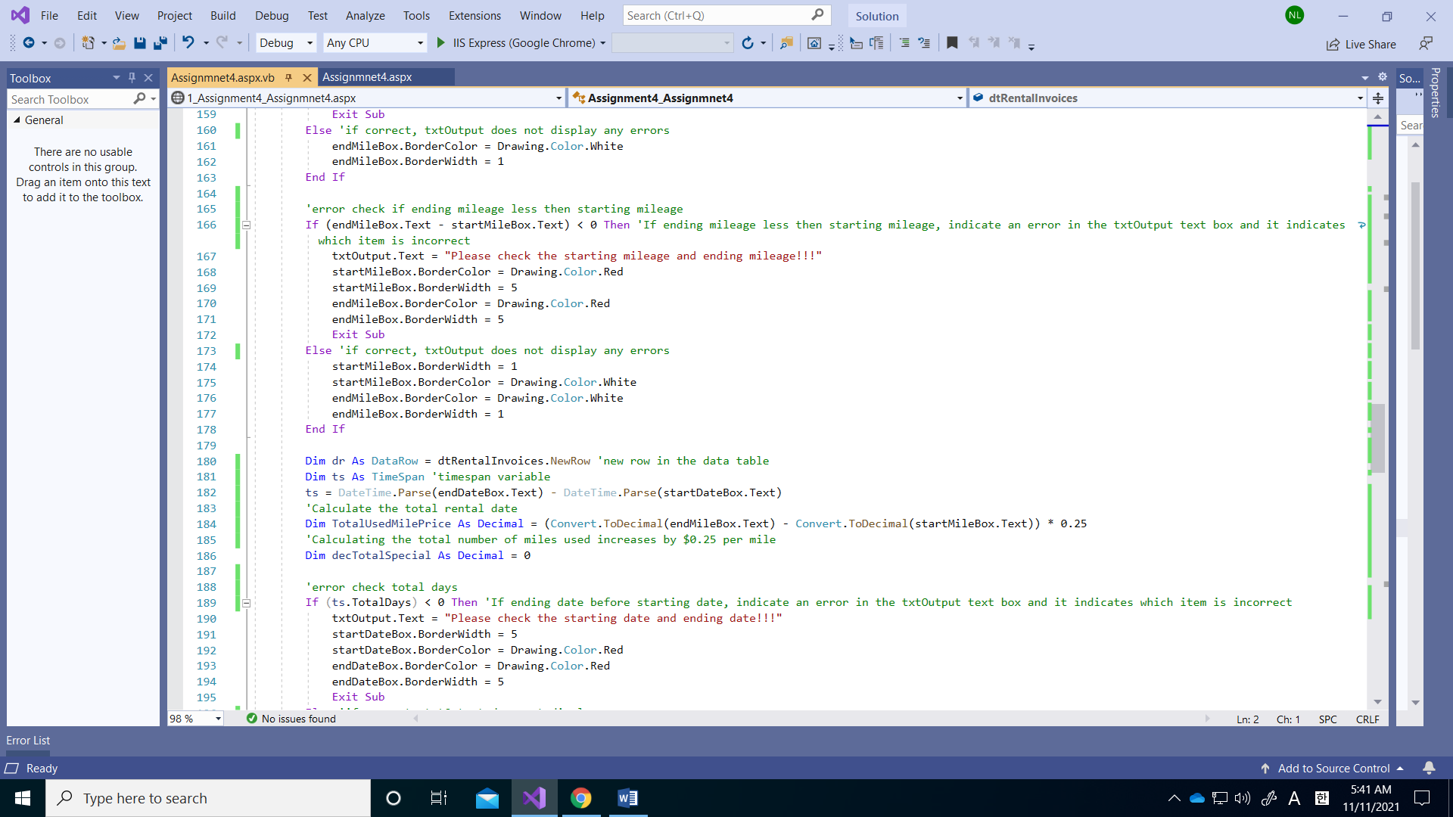

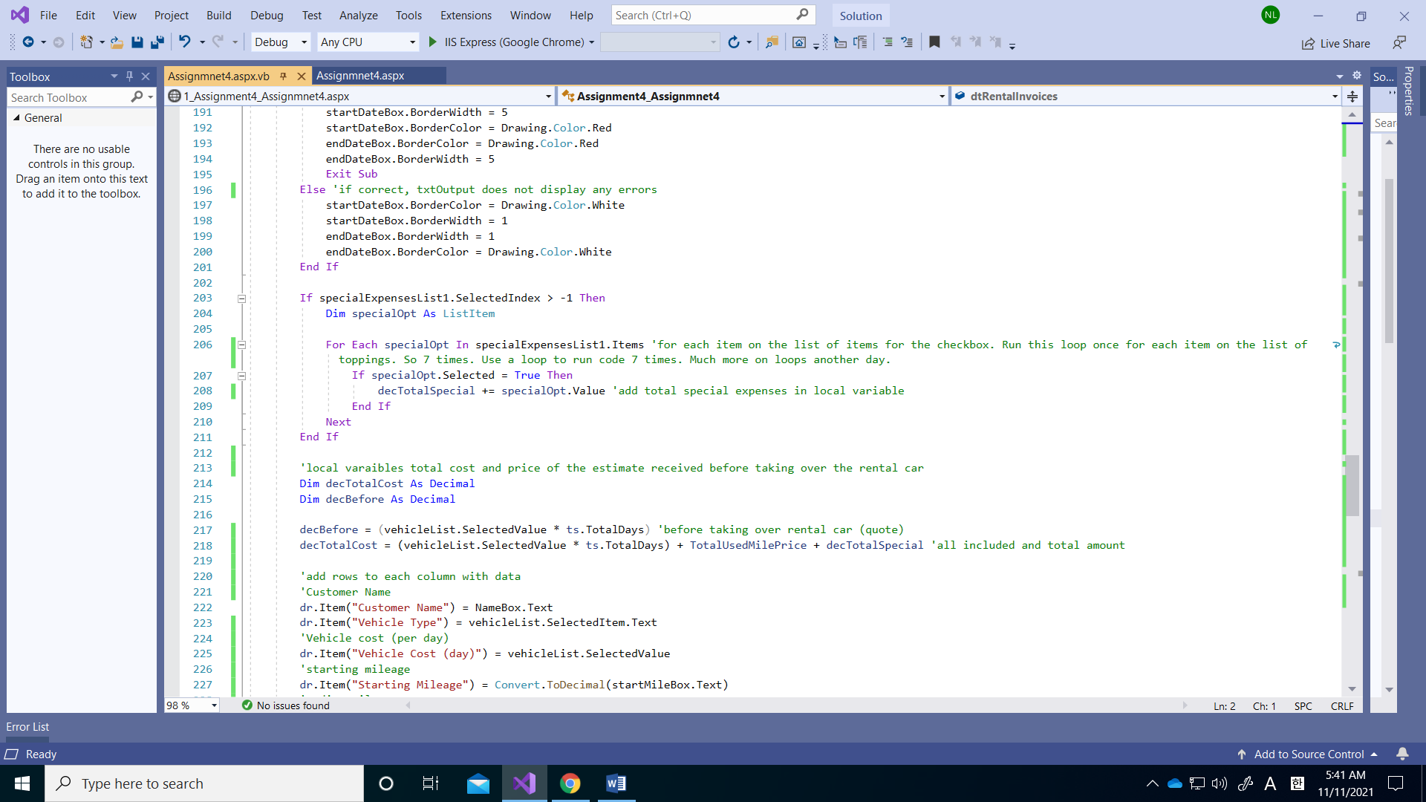

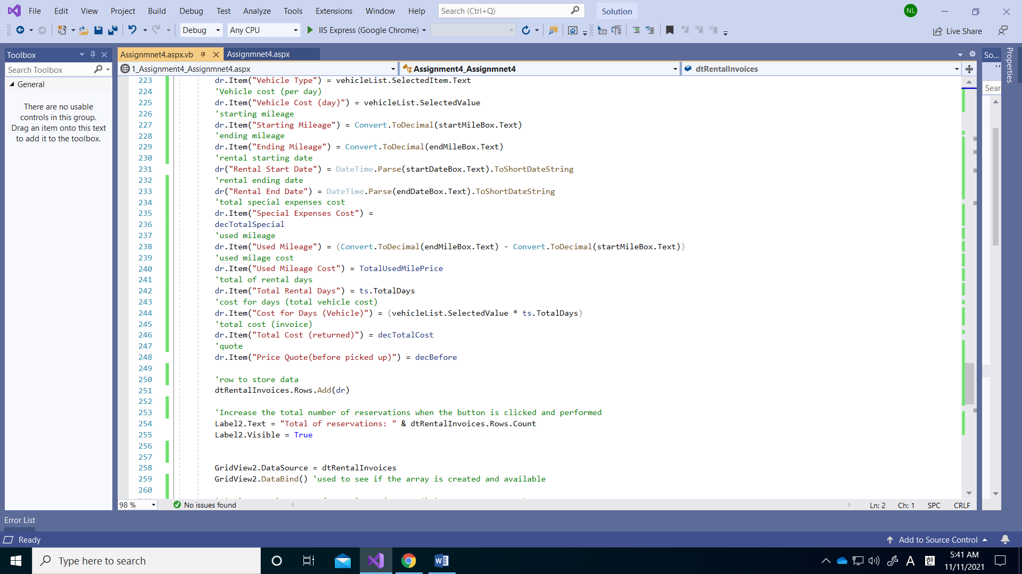

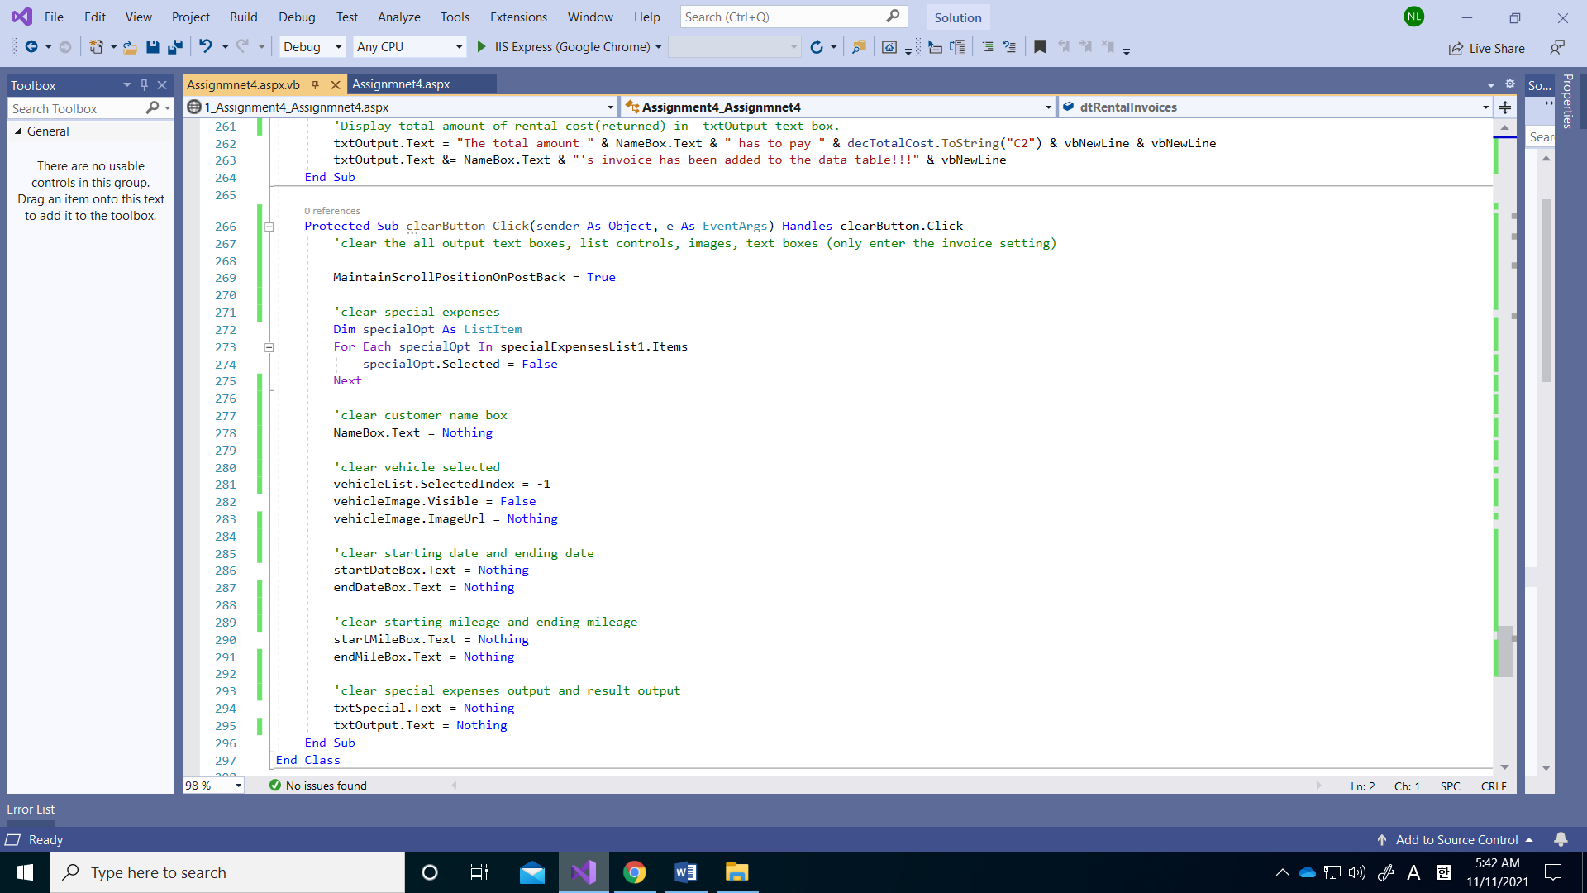

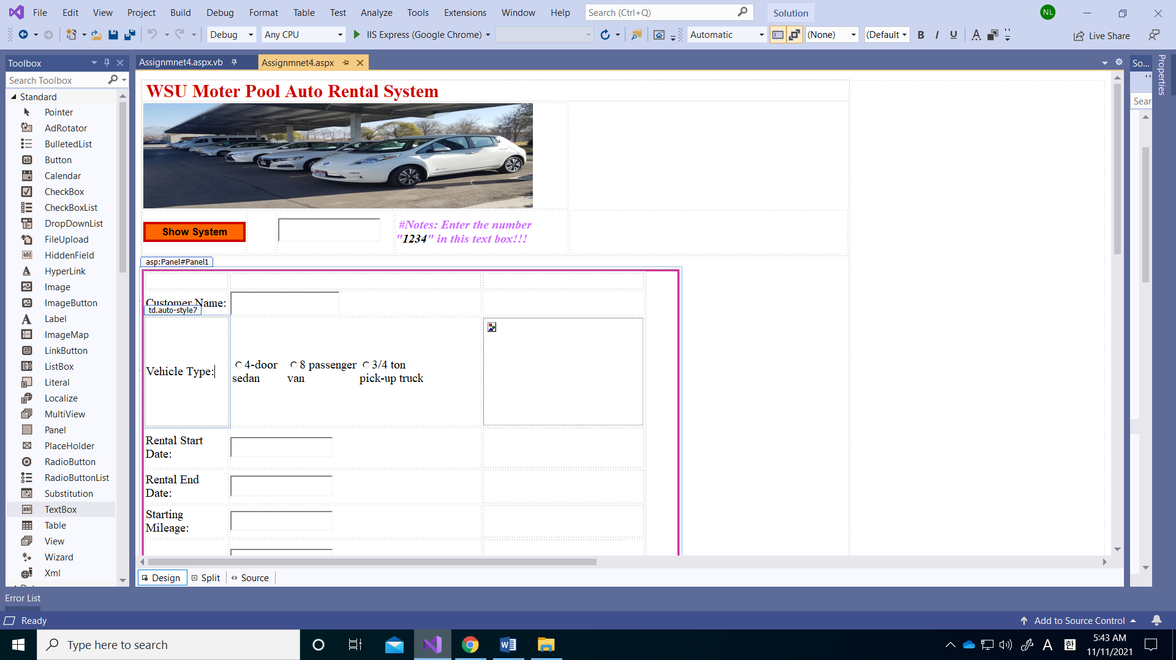

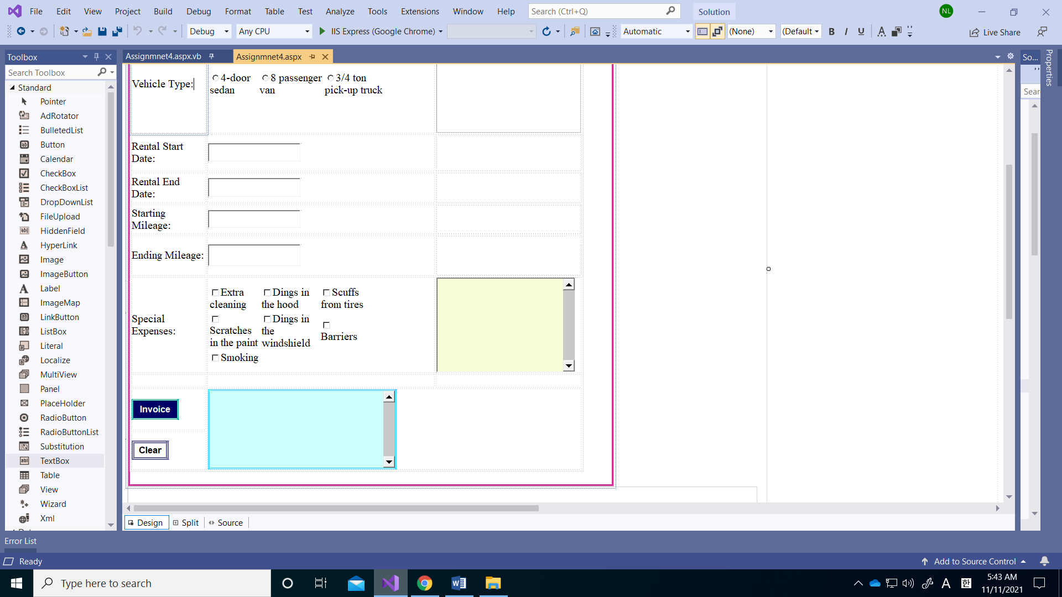

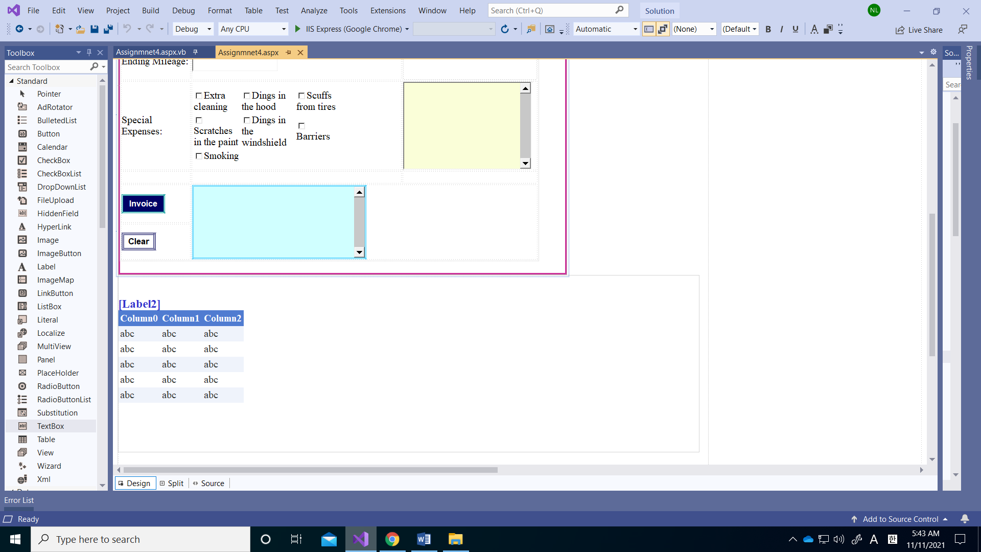

**Aspx.vb code:**

Imports System.Data

Partial Class Assignment4_Assignmnet4

Inherits System.Web.UI.Page

'The program features a motor pool employee lending a rental car and storing who rented the car, vehicle records, and the total amount of money that customers have to pay in a data table.

'This global variable table is used as a data structure to store invoice data rows.

Public Shared dtRentalInvoices As New DataTable

Private Sub Assignment4_Assignmnet4_Init(sender As Object, e As EventArgs) Handles Me.Init

'Create an array in a page_init procedure that runs once when a web page starts.

'Error check is performed to check if there is already a data column in the data table.

If dtRentalInvoices.Columns.Count > 0 Then Exit Sub

'This is an operation in which columns are added to the global data table. Names and data types for each column are specified. The first column is defined as an integer and an automatic number. There are 15 additional columns.

With dtRentalInvoices.Columns

.Add("Reservation ID", GetType(Integer))

.Add("Customer Name", GetType(String))

.Add("Vehicle Type", GetType(String))

.Add("Vehicle Cost (day)", GetType(Decimal))

.Add("Rental Start Date", GetType(String))

.Add("Rental End Date", GetType(String))

.Add("Total Rental Days", GetType(String))

.Add("Starting Mileage", GetType(Decimal))

.Add("Ending Mileage", GetType(Decimal))

.Add("Used Mileage", GetType(Decimal))

.Add("Used Mileage Cost", GetType(Decimal))

.Add("Special Expenses Cost", GetType(Decimal))

.Add("Cost for Days (Vehicle)", GetType(Decimal))

.Add("Price Quote(before picked up)", GetType(Decimal))

.Add("Total Cost (returned)", GetType(Decimal))

End With

'The first column is defined as an integer and an automatic number

With dtRentalInvoices.Columns("Reservation ID")

.AutoIncrement = True

.AutoIncrementSeed = 1

.AutoIncrementStep = 1

End With

End Sub

Protected Sub showButton_Click(sender As Object, e As EventArgs) Handles showButton.Click

'It's a function that shows the program when you enter the password.

If passwordBox.Text = "1234" Then 'If you enter the password correctly, it shows Panel 1 and Panel 2.

Panel1.Visible = True

Panel2.Visible = True

Else 'If the password cannot be entered correctly, output an error message.

Response.Write("Please enter the correct password number!!!")

Exit Sub

End If

End Sub

Protected Sub vehicleList_SelectedIndexChanged(sender As Object, e As EventArgs) Handles vehicleList.SelectedIndexChanged

MaintainScrollPositionOnPostBack = True

'It is a function that shows an image of a car when each list item is selected from the car selection of the car.

Select Case vehicleList.SelectedIndex

Case 0 'show 4-door sedan image

vehicleImage.ImageUrl = "4door.jpg"

vehicleImage.Visible = True

Case 1 'show 8 passenger van image

vehicleImage.ImageUrl = "8van.jpg"

vehicleImage.Visible = True

Case 2 'show 3/4 ton pick-up truck image

vehicleImage.ImageUrl = "34ton.jpg"

vehicleImage.Visible = True

End Select

End Sub

Protected Sub specialExpensesList1_SelectedIndexChanged(sender As Object, e As EventArgs) Handles specialExpensesList1.SelectedIndexChanged

MaintainScrollPositionOnPostBack = True

Dim strSpecial As String = Nothing 'this variable used to build the list of special expenses

Dim decTotalSpecial As Decimal = 0

If specialExpensesList1.SelectedIndex > -1 Then

Dim specialOpt As ListItem

For Each specialOpt In specialExpensesList1.Items 'for each item on the list of items for the checkbox. Run this loop once for each item on the list of toppings. So 7 times. Use a loop to run code 7 times. Much more on loops another day.

If specialOpt.Selected = True Then 'If special option is selected, show the type of special expense and price of each special expense.

strSpecial &= specialOpt.Text & ": " & specialOpt.Value & vbNewLine

decTotalSpecial += specialOpt.Value 'add local total special expenses price

End If

Next

End If

'Displays the price of each option for the option selected in the txtSpeical multi-line text box.

txtSpecial.Text = "[List of Special Expenses]" & vbNewLine

txtSpecial.Text &= strSpecial & vbNewLine

txtSpecial.Text &= "Total: " & decTotalSpecial.ToString("C2")

End Sub

Protected Sub invoiceButton_Click(sender As Object, e As EventArgs) Handles invoiceButton.Click

'When you click this button, it has the function of storing invoices for each customer in the data table

'error check customer name text box

If NameBox.Text = Nothing Then 'If nothing is write, indicate an error in the txtOutput text box and it indicates which item is incorrect

txtOutput.Text = "Please enter the Name!!!"

NameBox.BorderColor = Drawing.Color.Red

NameBox.BorderWidth = 5

Exit Sub

Else 'If correct, txtOutput does not display any errors

NameBox.BorderColor = Drawing.Color.White

NameBox.BorderWidth = 1

End If

'error check vehicle list

If vehicleList.SelectedIndex < 0 Then 'If nothing is selected, indicate an error in the txtOutput text box and it indicates which item is incorrect

txtOutput.Text = "Please enter the vehicle type!!!"

vehicleList.BorderColor = Drawing.Color.Red

vehicleList.BorderWidth = 5

Exit Sub

Else 'If correct, txtOutput does not display any errors

vehicleList.BorderColor = Drawing.Color.White

vehicleList.BorderWidth = 1

End If

'error check start rent date text box

If startDateBox.Text = Nothing Then 'If nothing is write, indicate an error in the txtOutput text box and it indicates which item is incorrect

txtOutput.Text = "Please enter the start date!!!"

startDateBox.BorderWidth = 5

startDateBox.BorderColor = Drawing.Color.Red

Exit Sub

Else 'If correct, txtOutput does not display any errors

startDateBox.BorderColor = Drawing.Color.White

startDateBox.BorderWidth = 1

End If

'error check end rent date text box

If endDateBox.Text = Nothing Then 'If nothing is write, indicate an error in the txtOutput text box and it indicates which item is incorrect

txtOutput.Text = "Please enter the end date!!!"

endDateBox.BorderColor = Drawing.Color.Red

endDateBox.BorderWidth = 5

Exit Sub

Else 'if correct, txtOutput does not display any errors

endDateBox.BorderWidth = 1

endDateBox.BorderColor = Drawing.Color.White

End If

'error check starting mileage text box

If startMileBox.Text = Nothing OrElse IsNumeric(startMileBox.Text) = False Then 'If nothing is write and is not numeric, indicate an error in the txtOutput text box and it indicates which item is incorrect

txtOutput.Text = "Please enter the start mileage (Numeric)!!!"

startMileBox.BorderColor = Drawing.Color.Red

startMileBox.BorderWidth = 5

Exit Sub

Else 'if correct, txtOutput does not display any errors

startMileBox.BorderWidth = 1

startMileBox.BorderColor = Drawing.Color.White

End If

'error check ending mileage text box

If endMileBox.Text = Nothing OrElse IsNumeric(endMileBox.Text) = False Then 'If nothing is write and is not numeric, indicate an error in the txtOutput text box and it indicates which item is incorrect

txtOutput.Text = "Please enter the end mileage (Numeric)!!!"

endMileBox.BorderColor = Drawing.Color.Red

endMileBox.BorderWidth = 5

Exit Sub

Else 'if correct, txtOutput does not display any errors

endMileBox.BorderColor = Drawing.Color.White

endMileBox.BorderWidth = 1

End If

'error check if ending mileage less then starting mileage

If (endMileBox.Text - startMileBox.Text) < 0 Then 'If ending mileage less then starting mileage, indicate an error in the txtOutput text box and it indicates which item is incorrect

txtOutput.Text = "Please check the starting mileage and ending mileage!!!"

startMileBox.BorderColor = Drawing.Color.Red

startMileBox.BorderWidth = 5

endMileBox.BorderColor = Drawing.Color.Red

endMileBox.BorderWidth = 5

Exit Sub

Else 'if correct, txtOutput does not display any errors

startMileBox.BorderWidth = 1

startMileBox.BorderColor = Drawing.Color.White

endMileBox.BorderColor = Drawing.Color.White

endMileBox.BorderWidth = 1

End If

Dim dr As DataRow = dtRentalInvoices.NewRow 'new row in the data table

Dim ts As TimeSpan 'timespan variable

ts = DateTime.Parse(endDateBox.Text) - DateTime.Parse(startDateBox.Text)

'Calculate the total rental date

Dim TotalUsedMilePrice As Decimal = (Convert.ToDecimal(endMileBox.Text) - Convert.ToDecimal(startMileBox.Text)) * 0.25

'Calculating the total number of miles used increases by $0.25 per mile

Dim decTotalSpecial As Decimal = 0

'error check total days

If (ts.TotalDays) < 0 Then 'If ending date before starting date, indicate an error in the txtOutput text box and it indicates which item is incorrect

txtOutput.Text = "Please check the starting date and ending date!!!"

startDateBox.BorderWidth = 5

startDateBox.BorderColor = Drawing.Color.Red

endDateBox.BorderColor = Drawing.Color.Red

endDateBox.BorderWidth = 5

Exit Sub

Else 'if correct, txtOutput does not display any errors

startDateBox.BorderColor = Drawing.Color.White

startDateBox.BorderWidth = 1

endDateBox.BorderWidth = 1

endDateBox.BorderColor = Drawing.Color.White

End If

If specialExpensesList1.SelectedIndex > -1 Then

Dim specialOpt As ListItem

For Each specialOpt In specialExpensesList1.Items 'for each item on the list of items for the checkbox. Run this loop once for each item on the list of toppings. So 7 times. Use a loop to run code 7 times. Much more on loops another day.

If specialOpt.Selected = True Then

decTotalSpecial += specialOpt.Value 'add total special expenses in local variable

End If

Next

End If

'local varaibles total cost and price of the estimate received before taking over the rental car

Dim decTotalCost As Decimal

Dim decBefore As Decimal

decBefore = (vehicleList.SelectedValue * ts.TotalDays) 'before taking over rental car (quote)

decTotalCost = (vehicleList.SelectedValue * ts.TotalDays) + TotalUsedMilePrice + decTotalSpecial 'all included and total amount

'add rows to each column with data

'Customer Name

dr.Item("Customer Name") = NameBox.Text

dr.Item("Vehicle Type") = vehicleList.SelectedItem.Text

'Vehicle cost (per day)

dr.Item("Vehicle Cost (day)") = vehicleList.SelectedValue

'starting mileage

dr.Item("Starting Mileage") = Convert.ToDecimal(startMileBox.Text)

'ending mileage

dr.Item("Ending Mileage") = Convert.ToDecimal(endMileBox.Text)

'rental starting date

dr("Rental Start Date") = DateTime.Parse(startDateBox.Text).ToShortDateString

'rental ending date

dr("Rental End Date") = DateTime.Parse(endDateBox.Text).ToShortDateString

'total special expenses cost

dr.Item("Special Expenses Cost") =

decTotalSpecial

'used mileage

dr.Item("Used Mileage") = (Convert.ToDecimal(endMileBox.Text) - Convert.ToDecimal(startMileBox.Text))

'used milage cost

dr.Item("Used Mileage Cost") = TotalUsedMilePrice

'total of rental days

dr.Item("Total Rental Days") = ts.TotalDays

'cost for days (total vehicle cost)

dr.Item("Cost for Days (Vehicle)") = (vehicleList.SelectedValue * ts.TotalDays)

'total cost (invoice)

dr.Item("Total Cost (returned)") = decTotalCost

'quote

dr.Item("Price Quote(before picked up)") = decBefore

'row to store data

dtRentalInvoices.Rows.Add(dr)

'Increase the total number of reservations when the button is clicked and performed

Label2.Text = "Total of reservations: " & dtRentalInvoices.Rows.Count

Label2.Visible = True

GridView2.DataSource = dtRentalInvoices

GridView2.DataBind() 'used to see if the array is created and available

'Display total amount of rental cost(returned) in txtOutput text box.

txtOutput.Text = "The total amount " & NameBox.Text & " has to pay " & decTotalCost.ToString("C2") & vbNewLine & vbNewLine

txtOutput.Text &= NameBox.Text & "'s invoice has been added to the data table!!!" & vbNewLine

End Sub

Protected Sub clearButton_Click(sender As Object, e As EventArgs) Handles clearButton.Click

'clear the all output text boxes, list controls, images, text boxes (only enter the invoice setting)

MaintainScrollPositionOnPostBack = True

'clear special expenses

Dim specialOpt As ListItem

For Each specialOpt In specialExpensesList1.Items

specialOpt.Selected = False

Next

'clear customer name box

NameBox.Text = Nothing

'clear vehicle selected

vehicleList.SelectedIndex = -1

vehicleImage.Visible = False

vehicleImage.ImageUrl = Nothing

'clear starting date and ending date

startDateBox.Text = Nothing

endDateBox.Text = Nothing

'clear starting mileage and ending mileage

startMileBox.Text = Nothing

endMileBox.Text = Nothing

'clear special expenses output and result output

txtSpecial.Text = Nothing

txtOutput.Text = Nothing

End Sub

End Class

**Run my webpage:**



